This assignment purpose is to warm up your Python and Bash skills to create scripts that automate common cybersecurity tasks. You will demonstrate your skills in using scripting fundamentals, such as conditional statements, loops, etc. that was covered in Week 3’s PowerPoint.

To receive full credit, ensure your scripts are properly cited at the top and commented throughout. Include screenshots of your script outputs where requested in the lab instructions.

**Please include your Microsoft Learn Transcript at the bottom of this assignment.**

**NOTE:** Be sure that you change your script’s file extension to .txt so it will be accepted by BrightSpace.

**Submission Requirements:**

* Submit the following through Brightspace:
  + The Python script files
  + The Bash script files
  + The Assignment 3 document (**this document**) with all required screenshots.

**Python #1 - Brute-Force Detection Script Output Screenshot**

**Python #2. Password Strength Checker Script Output Screenshot**

**Python #3. Log File Analyzer Script Output Screenshot**

**Bash #1. SSH Brute-Force Log Analysis Script Output Screenshot**

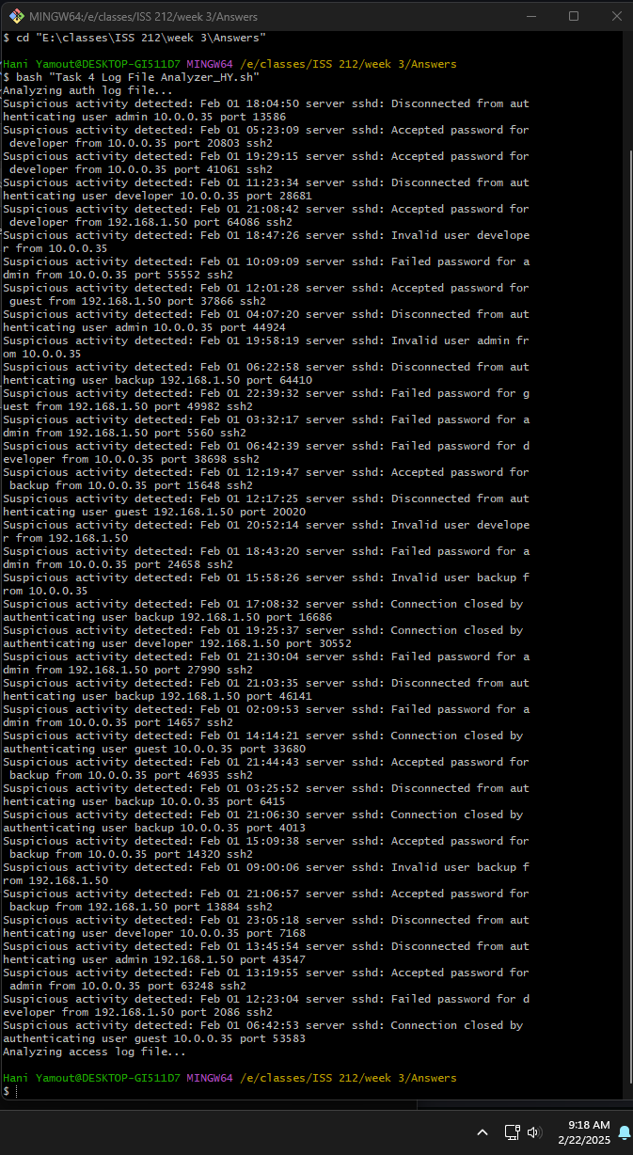

**Bash #2. File Permission Script Output Screenshot**

**Bash #3. Port Scanner Script Output Screenshot**

**MS Learn Transcript (GitHub Primer completed)**

